

|  |
| --- |
| **AWS Solution Architect (Professional) Training Curriculum** |

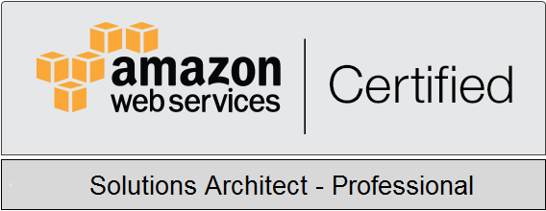



|  |  |
| --- | --- |
|  | **AWS Solution Architect - Professional** |

|  |
| --- |
|  |

1. **Design for Organizational Complexity**

* Determine cross-account authentication and access strategy for complex organizations (for example, an organization with varying compliance requirements, multiple business units, and varying scalability requirements)
* Determine how to design networks for complex organizations (for example, an organization with varying compliance requirements, multiple business units, and varying scalability requirements)
* Determine how to design a multi-account AWS environment for complex organizations (for example, an organization with varying compliance requirements, multiple business units, and varying scalability requirements)

1. **Design for New Solutions**

* Determine security requirements and controls when designing and implementing a solution
* Determine a solution design and implementation strategy to meet reliability requirements
* Determine a solution design to ensure business continuity
* Determine a solution design to meet performance objectives
* Determine a deployment strategy to meet business requirements when designing and implementing a solution Domain

1. **Migration Planning**

* Select existing workloads and processes for potential migration to the cloud
* Select migration tools and/or services for new and migrated solutions based on detailed AWS knowledge
* Determine new cloud architecture for an existing solution
* Determine a strategy for migrating existing on-premises workloads to the cloud

1. **Cost Control**

* Select a cost-effective pricing model for a solution
* Determine which controls to design and implement that will ensure cost optimization
* Identify opportunities to reduce cost in an existing solution

1. **Continuous Improvement for Existing Solutions**

* Troubleshoot solution architectures
* Determine a strategy to improve an existing solution for operational excellence
* Determine a strategy to improve the reliability of an existing solution
* Determine a strategy to improve the performance of an existing solution
* Determine a strategy to improve the security of an existing solution
* Determine how to improve the deployment of an existing solution